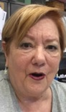
Sue Himel

Fellow Bridge Players,
I have been playing bridge since I was 11 years old, duplicate bridge since I was 19, and teaching bridge since I was 27 years old. My avocation is bridge. I became involved in bridge administra- tion early on and have served on various unit and district boards as membership chair, tournament coordinator, district tournament coordinator and district president.

I have been elected to the national board where I served as chair of the Governance Committee and Chair of the By Laws and Compliance Committee. If there is a volunteer job in bridge I have probably done it.

I was instrumental in helping to establish a 501 (c) 3 for Unit 241 (Omaha, NE) for our education in the school program. I was also instrumental in helping to set up the 501 (c) 3 for the Hall of Fame/Jr Foundation for the ACBL.

Locally, I have been directing and teaching here for about 5 years. I think that what is needed on the unit board at this time is someone that does not look to the past, but to the future. We need someone who will recognize that a new approach is needed. I think I am that person.

Thank you for your consideration, Sue Himel

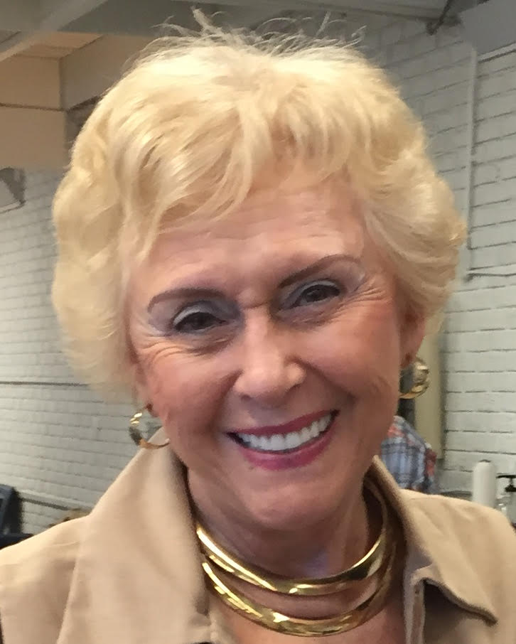
Jennie Flynn Sauviac

I wish to be re-elected to the LBA Board of Directors to represent all our members and bring your suggestions to the board for review.

I would like to place a question-and-answer box for intermediate players to post questions about difficult hands, and the best way to proceed with the play.
I have been a member of the LBA since 1972 and since that have been in all aspects of club activities promoting duplicate bridge.
I have served on the Board of Directors several times and have been President of the Board two terms, as well as served as Secretary and Vice-President. I have chaired many committees as well as chaired several of our sectional tournaments.

On the National level I was selected as a lifetime member of the ACBL Goodwill Committee as well as a lifetime member of the National Charity Committee. I was honored to be selected as the ACBL Goodwill Member of the Year in 2007.

Currently I am chairing the fundraising committee for the LBA for the NABC to be held here in New Orleans in March, 2023. Our goal was to raise $5,000. To date I have raised over $17,000.

I look forward to continuing to work for the betterment of our club for all of our members and the promotion of duplicate bridge. I will promote goodwill and friendship for all of our members. We will succeed together.

